Debraj’s New Hire Survival Guide

By [debraj.das@gmail.com](mailto:debraj.das@gmail.com) / [a-ddas@expedia.com](mailto:a-ddas@expedia.com)

Contents

Install everything under D:\dev 3

Binaries to Download/Install 3

How to Setup HipChat 3

Use the backup chat system called Lync 9

Installing the JDK 9

Unzip Eclipse somewhere under d:\Dev… 10

Configuring Eclipse 11

Install Maven somewhere under d:\Dev 14

Configure Maven (settings file to find Nexus) – if you don’t do this you will not be able to build 16

Install GIT 16

Request GitHub Write Access 17

Generate ssh keys for GIT 21

Add ~/.gitconfig (replace user/email with yours) 24

Browsing and Building the code 25

Installing SQL Management Studio (INCOMPLETE – this caused problems – we are trying to install using FrontDesk – FrontDesk worked, so skip this and go to the next section) 26

Installing SQL Management Studio using FrontDesk 29

Alternate Method to Installing SQL Management Studio 31

Timesheet 31

# Install everything under D:\dev

Elias and Kasim say not doing so causes problems with the virus checker.

# Binaries to Download/Install

* 7Zip
* Maven
* DataStax DevCenter
* Eclipse
* Git
* HipChat
* Java JDK
* MobaXterm
* SQL Management Studio
* Github client
* Vagrant
* VirtualBox

Here are the versions I installed as of April 10, 2015:

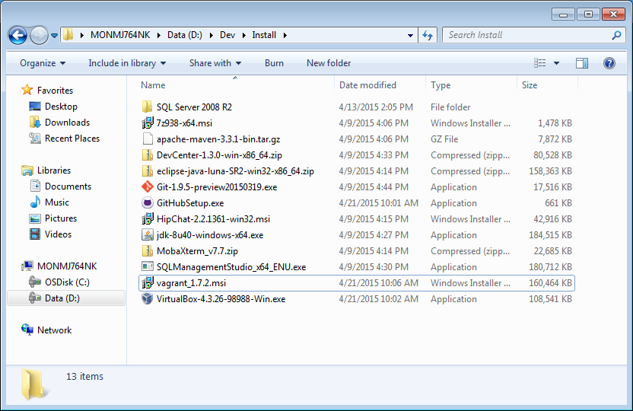

# How to Setup HipChat

1. Install HipChat client
2. .

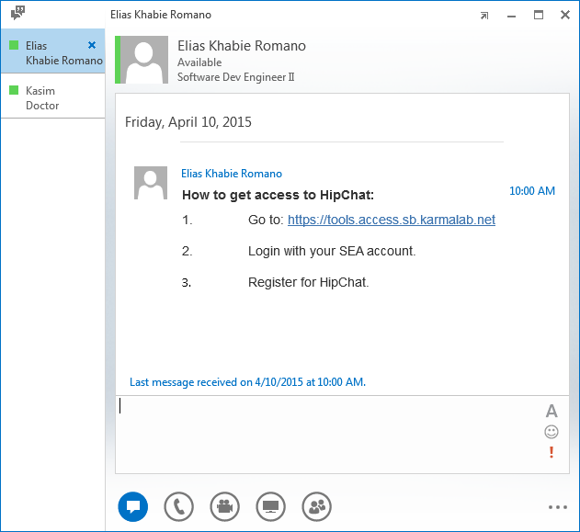

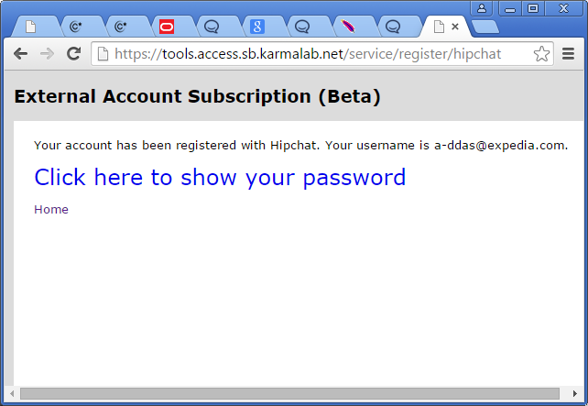

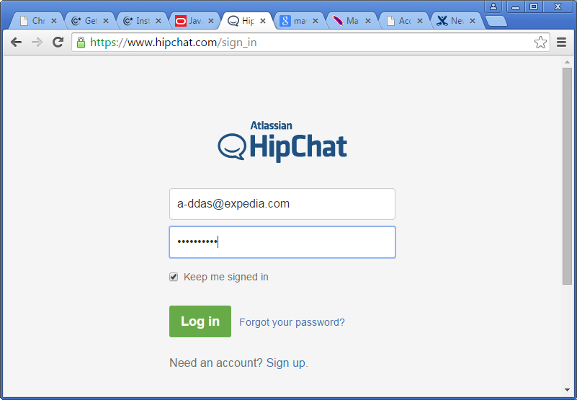

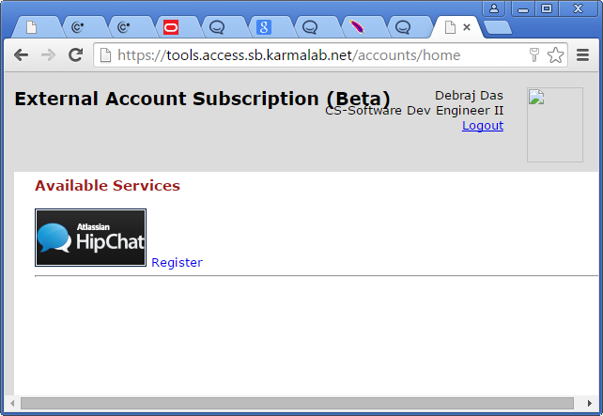

And click Register.

1. Start your local HipChat client and log in using the password you got in Step #3
2. Join the Room:

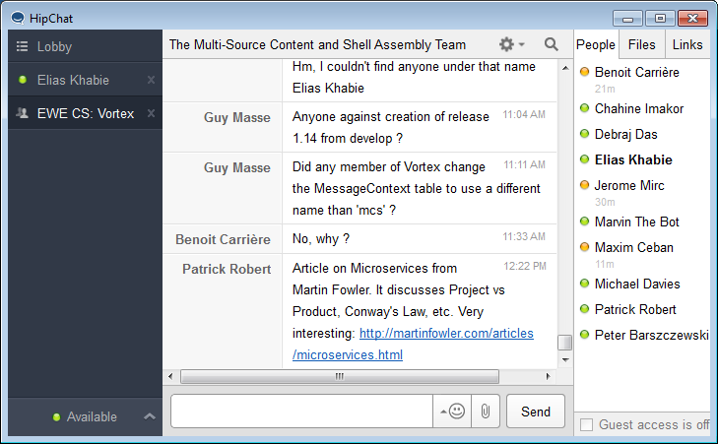

An interesting URL:



# Use the backup chat system called Lync

Windows Start button -> Lync -> Lync 2013

# Installing the JDK

* In Phoenix I was told to install Java & due to the different implementation of hashing in Java 8.

1. Install the JDK under D:\dev\, for example D:\Dev\Java\jdk1.8.0_40
2. Set JAVA_HOME

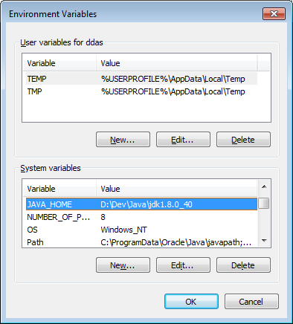

1. Set PATH

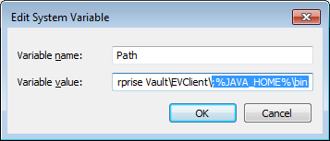

# Unzip Eclipse somewhere under d:\Dev…

*In Phoenix IntelliJ IDEA is mostly used.

For example D:\Dev\eclipse-java-luna-SR2-win32-x86_64

# Configuring Eclipse

1. Install the Checkstyle Plugin
   1. Follow <http://www.vogella.com/tutorials/Checkstyle/article.html>

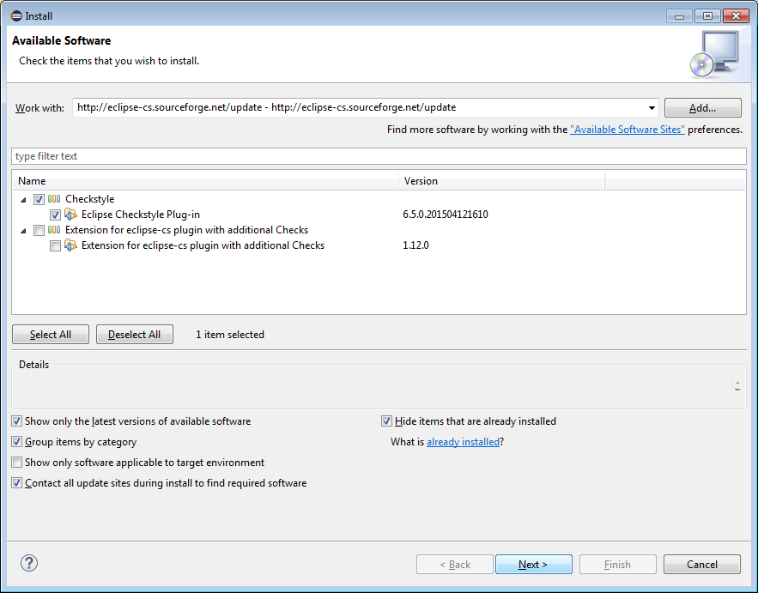

Hit next as needed…

* 1. Then grab the Expedia checkstyle config from here: <https://ewegithub.sb.karmalab.net/ContentSystems/cicd-checkstyle/raw/master/src/main/resources/lcs-checks.xml> and save it to your d:\dev directory somewhere. Then add it to eclipse as follows:

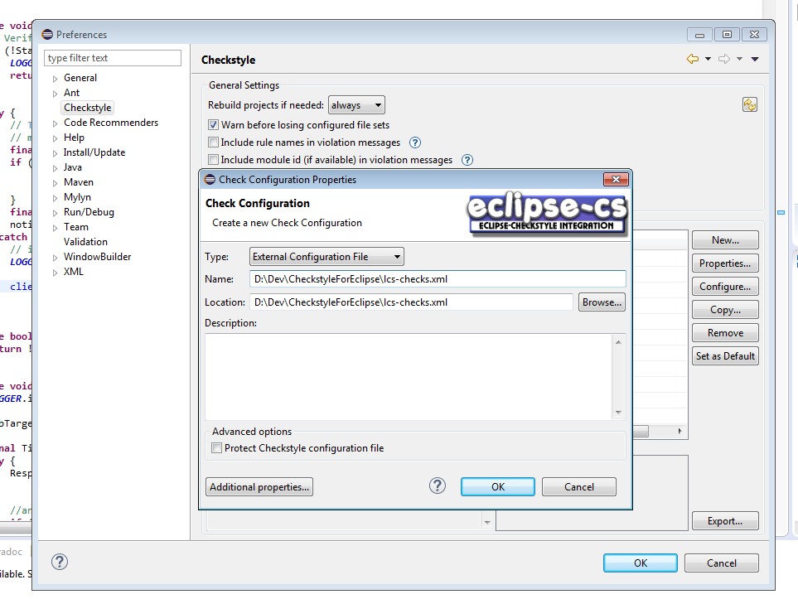

* 1. Make sure you set it as the default as follows:

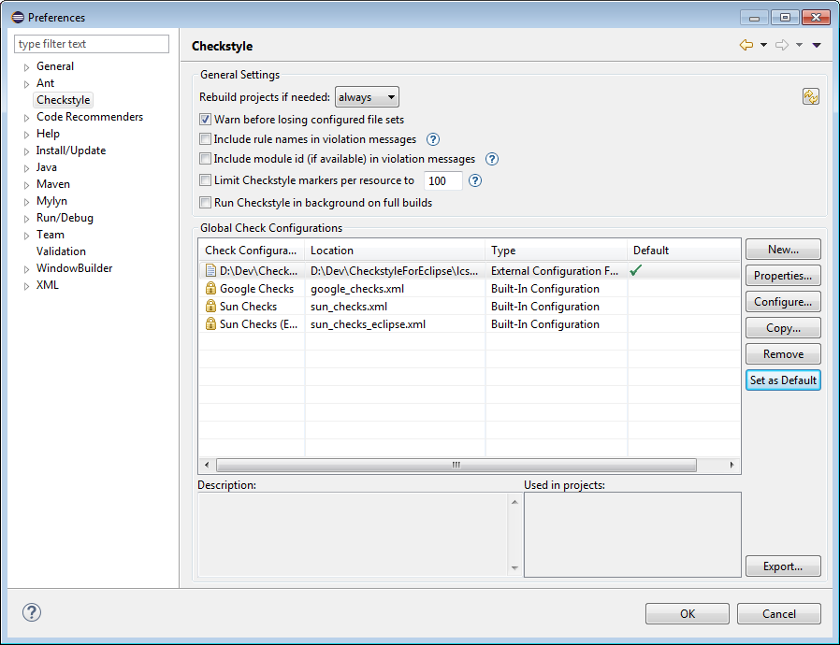

1. Import Kasim’s Expedia code formatter:

**Don’t use the Expedia code formatter from karmalab URL below because it has a problem with Tabs**

We used to import the Expedia code formatter from the below URL – but don’t use it <https://ewegithub.sb.karmalab.net/ContentSystems/cicd-checkstyle/raw/master/src/main/resources/lcs-eclipse-formatter.xml>

(for more documentation see https://confluence/display/CS/Checkstyle+and+Code+Formatter)

1. Configure your Import Order as follows:

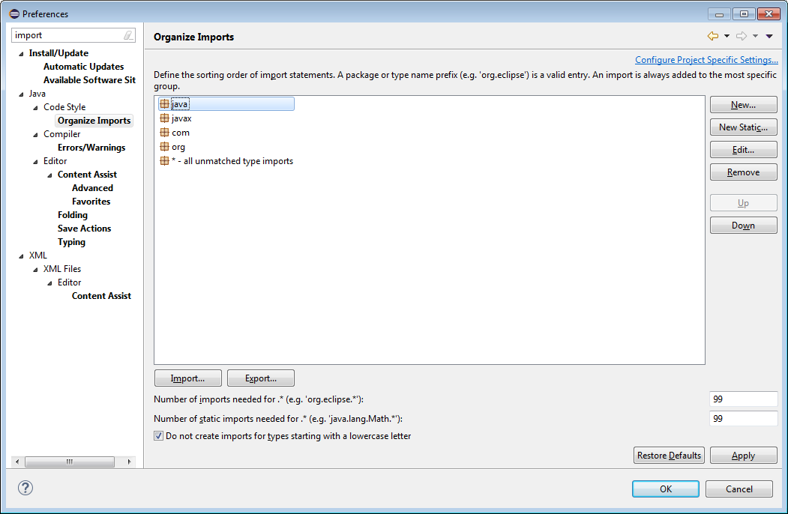

## Set your Eclipse JDK to your downloaded Java 1.8

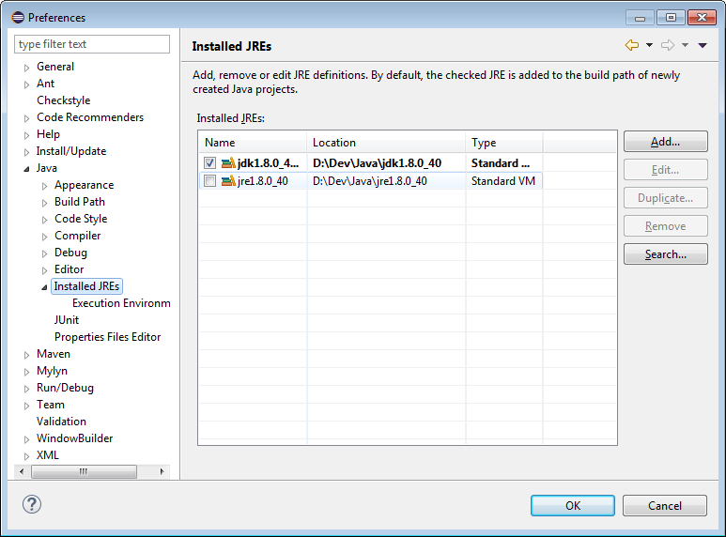

## Remember to also set your Eclipse Execution Environment

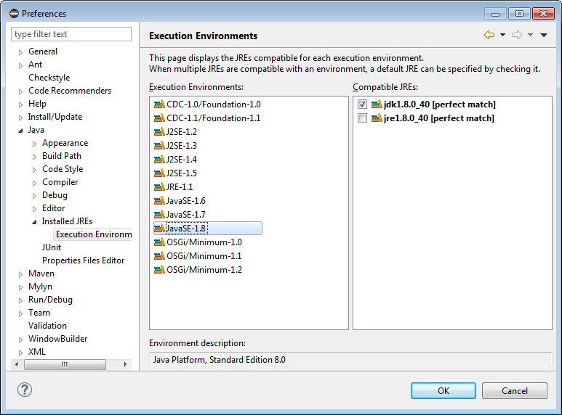

# Install Maven somewhere under d:\Dev

* In Phoenix I ran into issues for installing 3.2.2 and switched to 3.2.1.

1. Unzip to d:\Dev\... for example D:\Dev\apache-maven-3.3.1

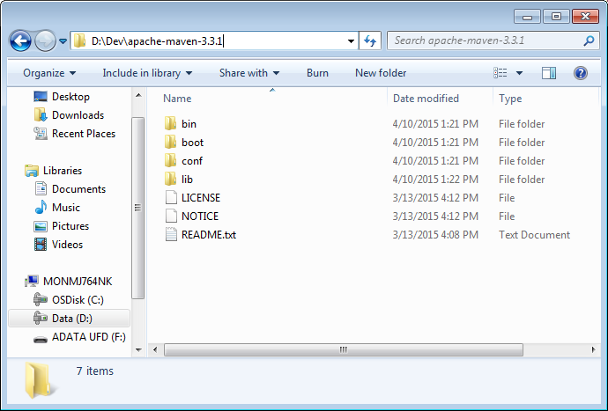

1. Follow the steps in: <http://maven.apache.org/download.cgi#Installation>

BUT WAIT! The instructions assume installation was done under “ *C:\Program Files\Apache Software Foundation*”, we ***DON’T*** want it installed on the C drive.

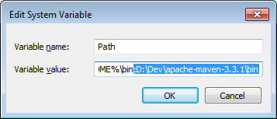

If all goes well, you should be able to do this:

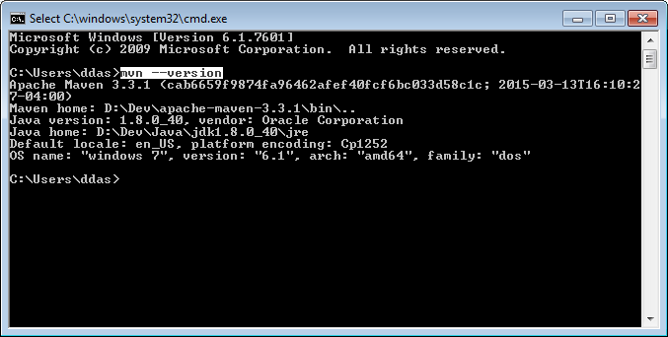

# Configure Maven (settings file to find Nexus) – if you don’t do this you will not be able to build

Search for “Maven” here: <https://confluence/display/CS/New+Hire+Guide>

Download Expedia’s internal repository and follow the instructions

* In Phoenix, the settings file described in <https://confluence/display/CS/New+Hire+Guide> seemed not updated. I used the settings file of another developer.

* Make sure to add M2_Home = Maven folder to your system variables.

# Install GIT

1. I ran the installer Git-1.9.5-preview20150319.exe
2. If all goes well you should be able to find Git Bash under Windows Start

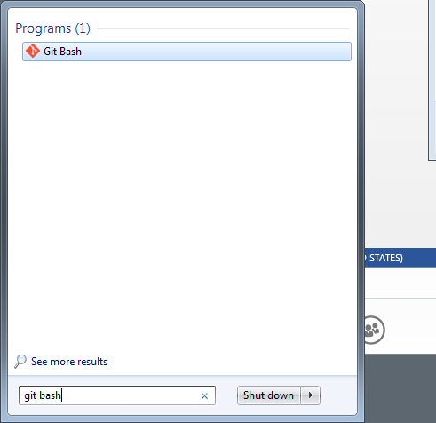

# Request GitHub Write Access

1. Request access to corporate Github: Follow steps starting #6 – your action items start from #7  
   <https://confluence/display/POS/Access+to+Git+and+clone+repo+to+Source+Tree>

My page looked like this:

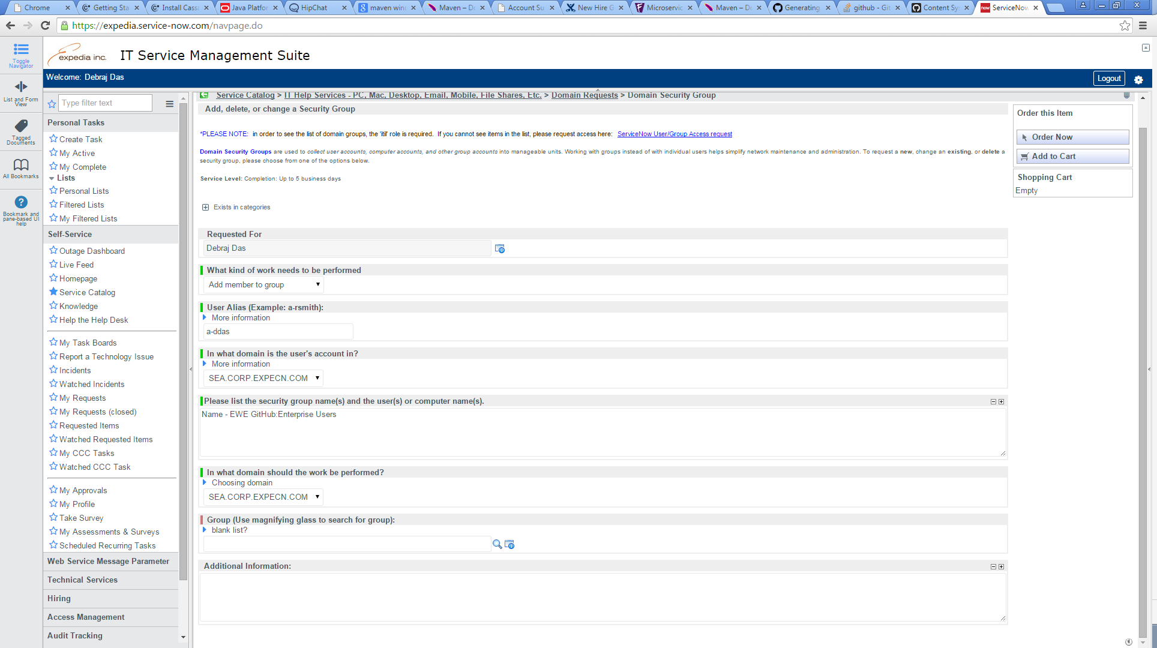

BUT I got submission errors. I contacted my manager (Jerome Mirc) and he tried submitting the request on my behalf.

<https://confluence/pages/viewpage.action?pageId=473051522>

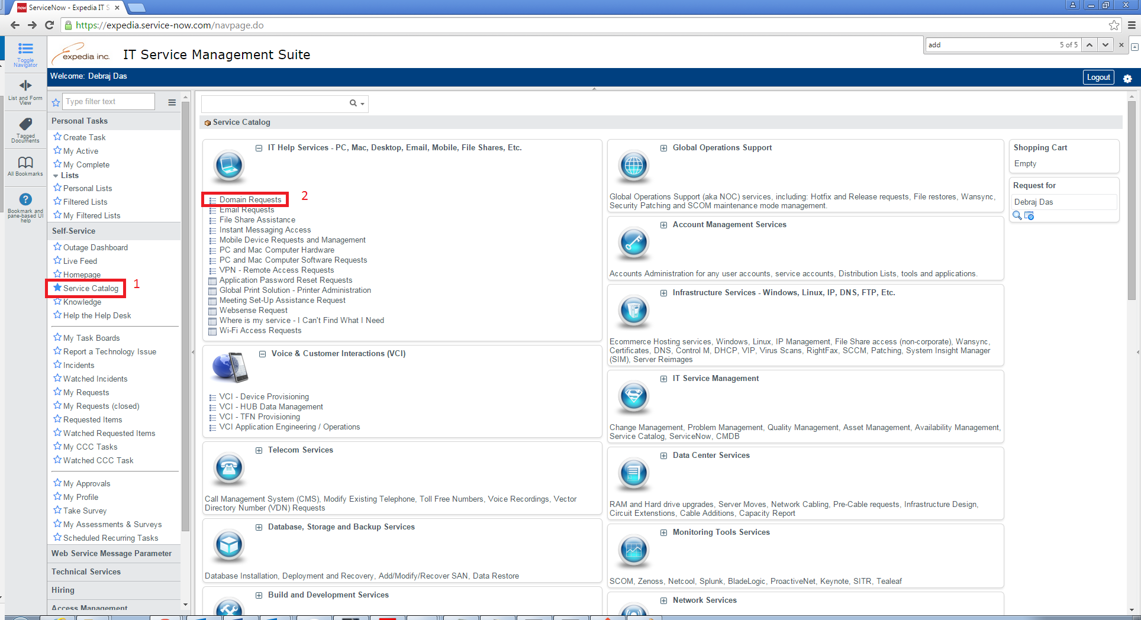

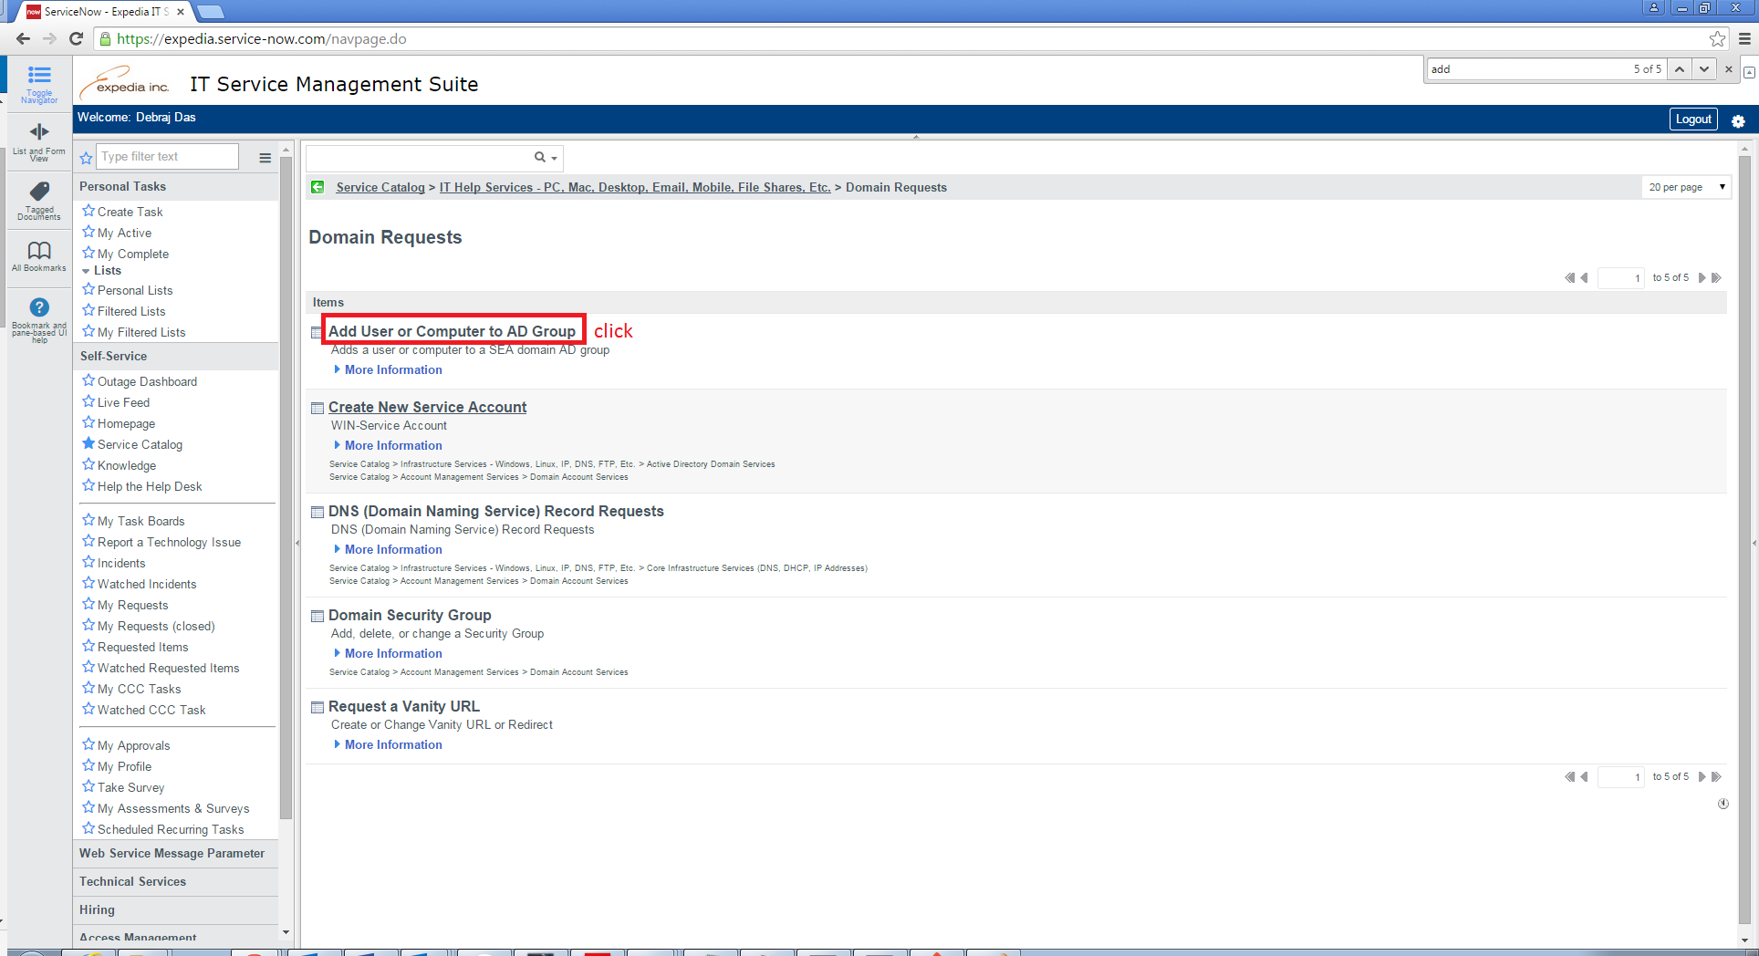

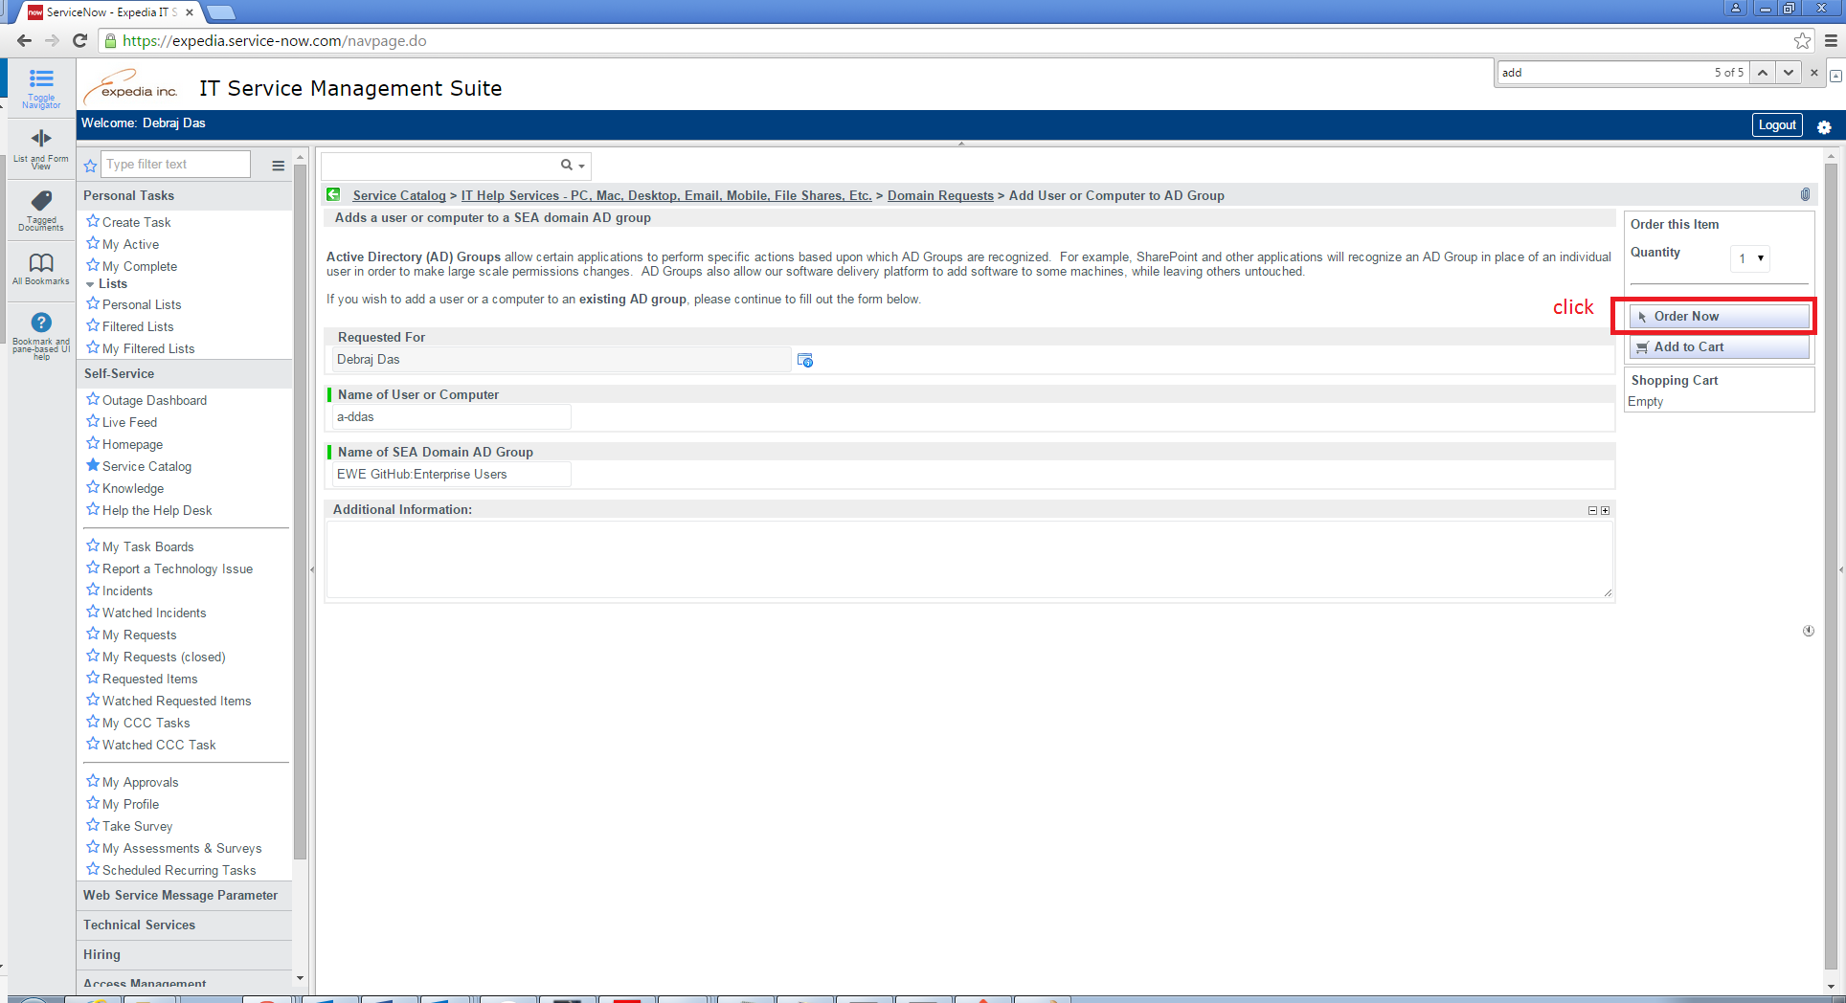

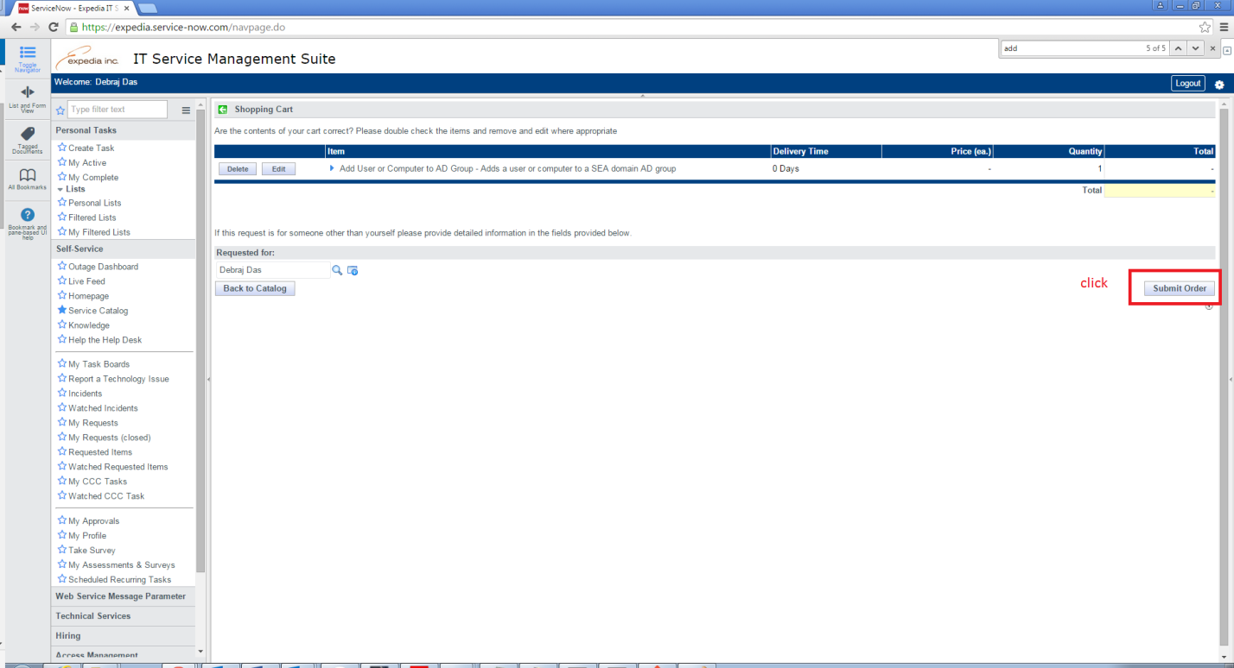

If all goes well, you should see:

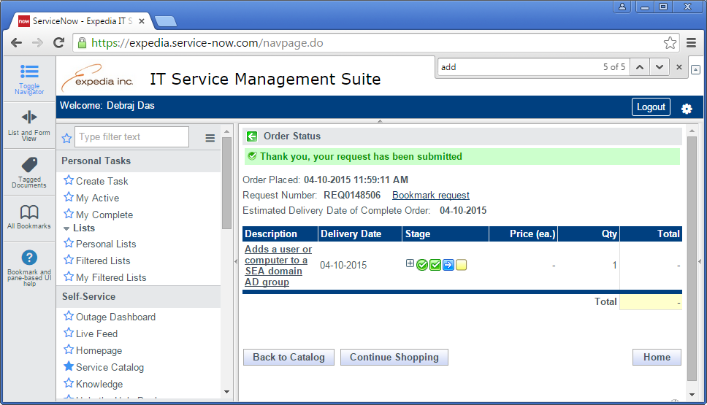

Now wait for a confirmation email…

**Note: you can still clone the code and browse with read-only access**

# Ask Your Manager to Get Added to Github ContentSystems Organization

If all goes well you should see the following:

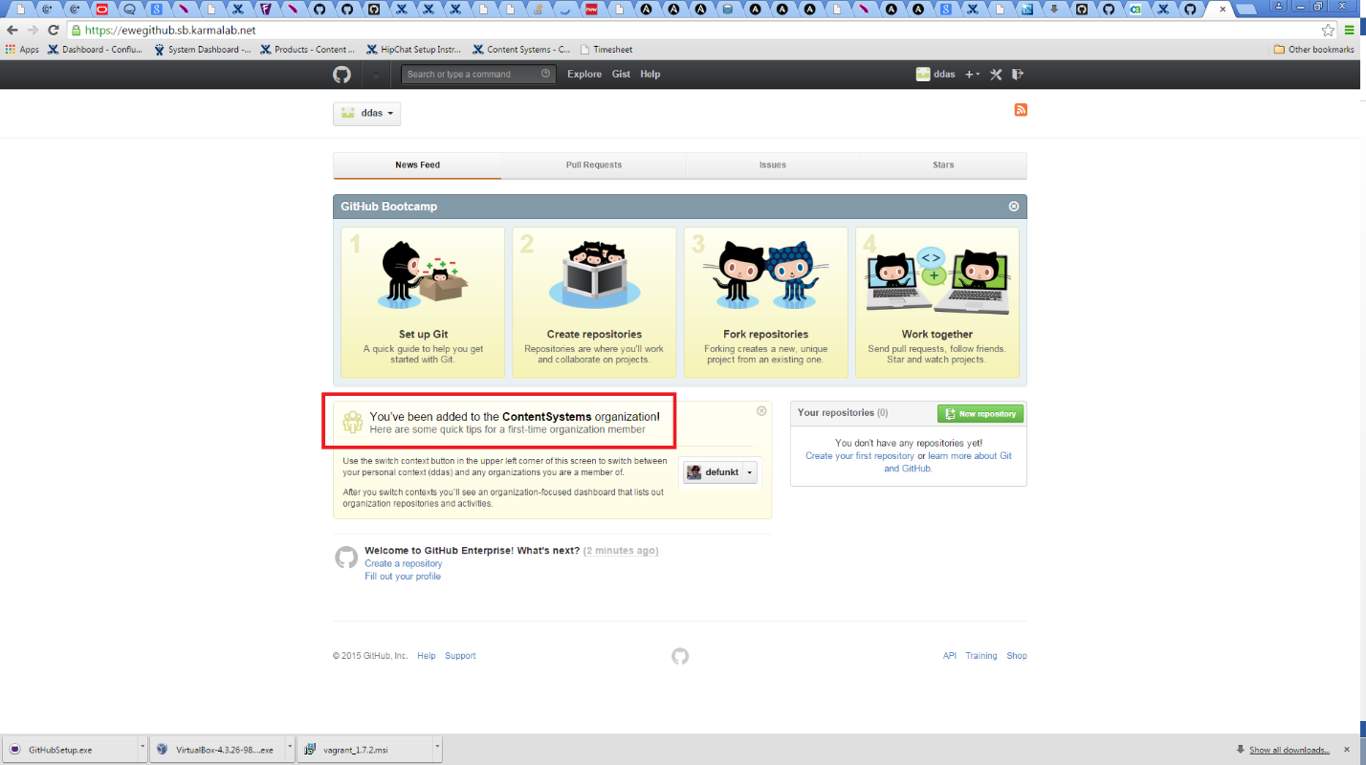

# Generate ssh keys for GIT

I followed the instructions here <https://help.github.com/articles/generating-ssh-keys/>

Run the *ls* command below – if you have no files found, that means you have no keys (like me):

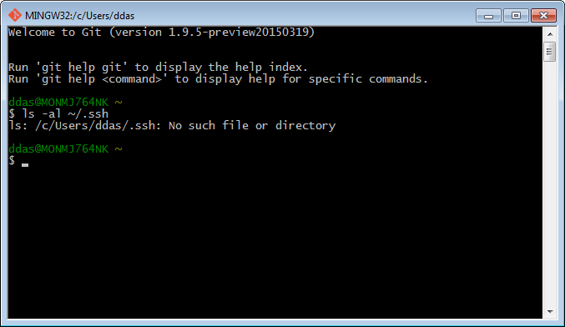

So I ran the following (I left passphrases blank, I just pushed ENTER).

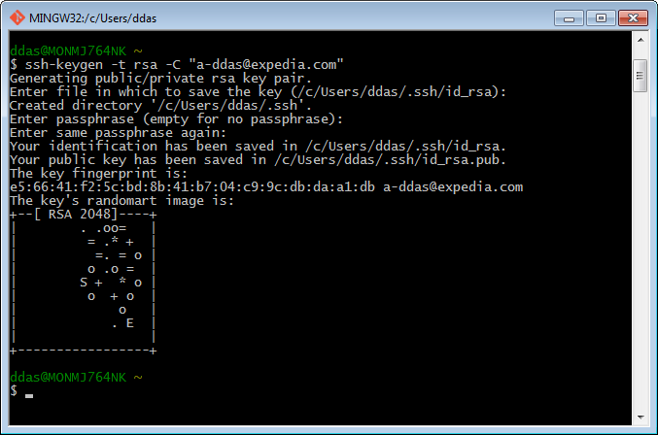

Even though the guide says they strongly recommend putting a passphrase, you really don’t have to at Expedia because our repository and developers are all behind the firewall so the risk is low. Besides, putting a blank passphrase saves a lot of extra typing when git’ing later.

Then I got this error:

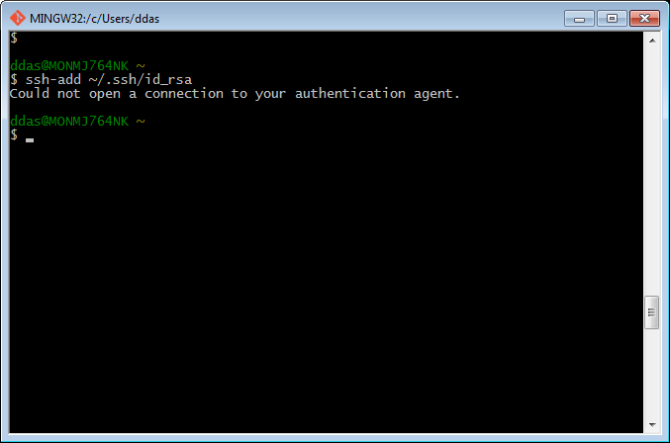

Even though the guide says you do not have to do eval, it turns out that you still have to do it:

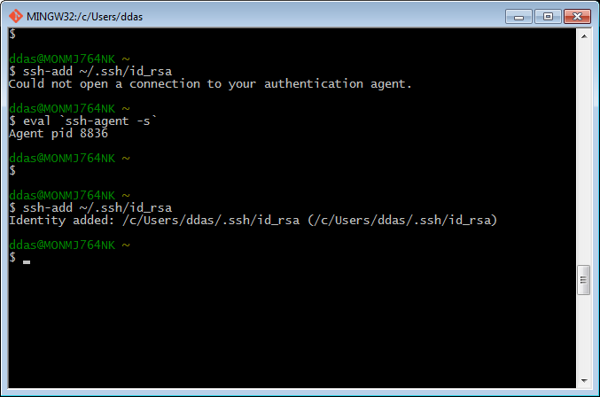

Copy your key contents to your clipboard. Use the clip shell command to do it without getting any extra whitespaces or carriage returns (IMPORTANT!): clip < ~/.ssh/id_rsa.pub

And then paste to the ssh keys in EWE github:

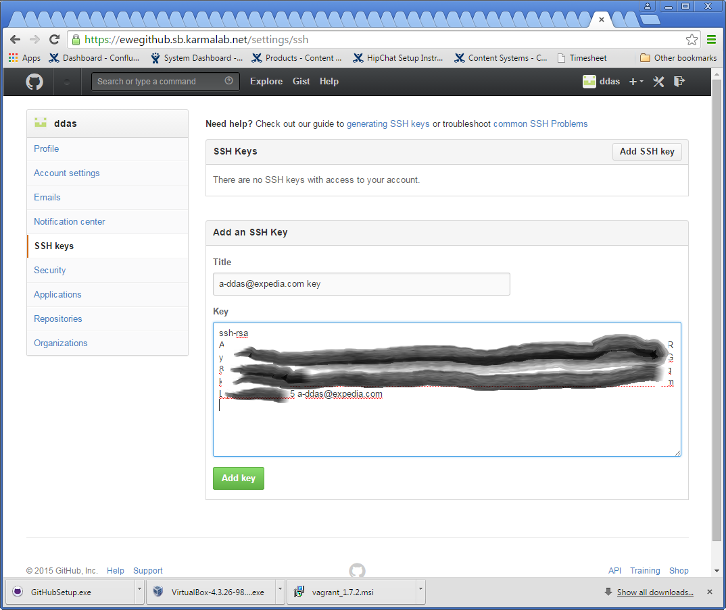

# Add ~/.gitconfig (replace user/email with yours)

[user]

name = ddas

email = a-ddas@expedia.com

[core]

autocrlf = true

[color]

ui = true

[alias]

stat = status

co = checkout

cod = checkout develop

md = merge develop

p = pull

br = branch

c = commit

[http]

sslVerify = false

*If you do not have a .config file, you can also add this config to /etc/gitconfig or .git/config.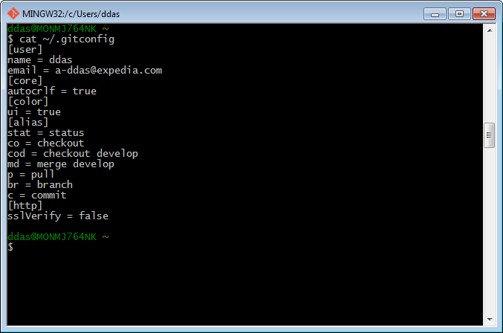

# 

# SSL certificate problem: unable to get local issuer certificate

If you get SSL problems with “git pull”, “git clone” or any other git command, do this:

git config --global http.sslVerify false

* After all of this I got permission denied when I tried to perform a “push”. Problem resolved by being added to Git dev team by Andre.

# Browsing and Building the code

Our Github project url is <https://ewegithub.sb.karmalab.net/ContentSystems/3rdparty-content-acquisition>

I store all code under d:\Dev\repos. Try the following:

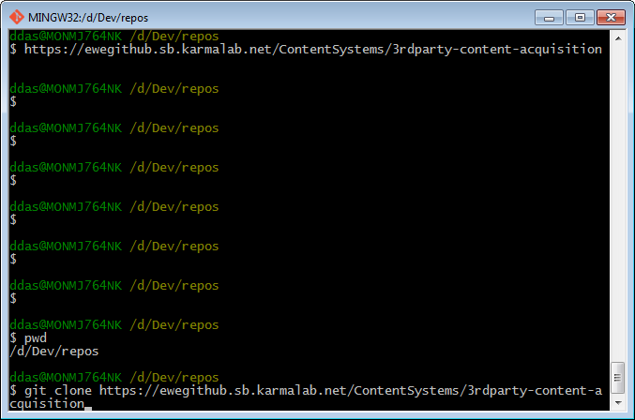

# Installing SQL Management Studio (INCOMPLETE – this caused problems – we are trying to install using FrontDesk – FrontDesk worked, so skip this and go to the next section)

Press your Start button and type “Front desk”. Front Desk is an app which can be used to download and install applications directly onto your local machine.

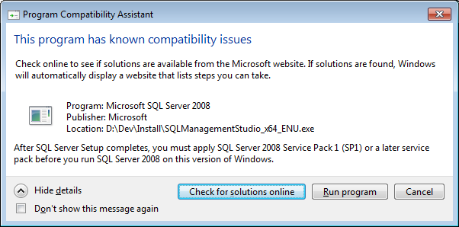

Check for solutions online will lead to this:

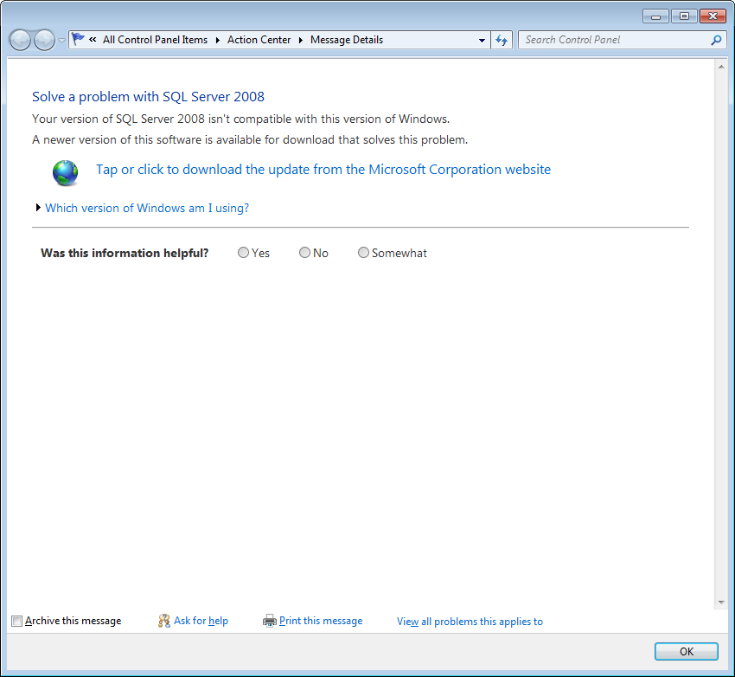

This will eventually lead you here, where you can go get the right service pack:

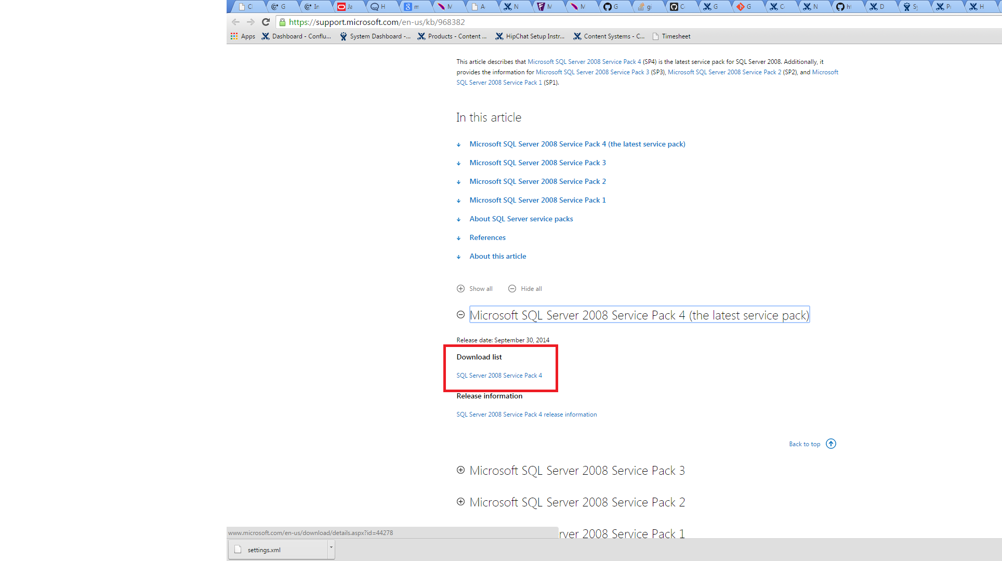

# Installing SQL Management Studio using FrontDesk

Press your Start button and type “Front desk”, hit enter and use the webapp... Front Desk is an app which can be used to download and install applications directly onto your local machine.

If all goes well, your Front Desk page should look like this: 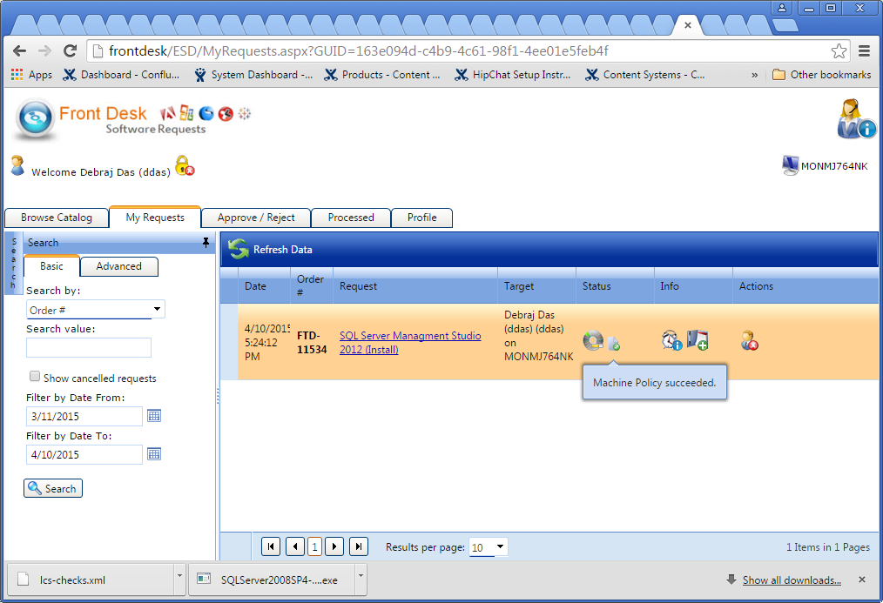

And you should see this in your start menu: 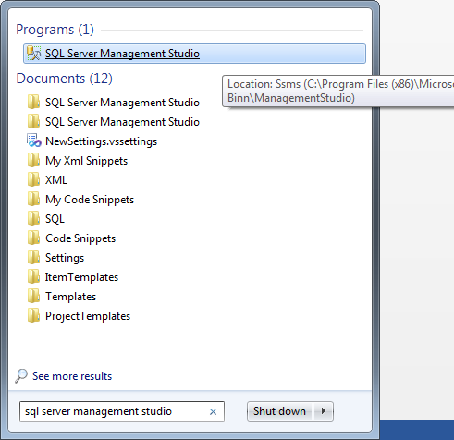

# Alternate Method to Installing SQL Management Studio

<https://confluence/display/CS/Steps+to+Install+SQL+Server+2008+Developer+R2>

# Timesheet

Clarity is the timesheet used by Expedia, found here: <http://basecamp/services/Clarity/default.aspx>

Then click on the CA PPM button (<http://clarity.expedia.biz/>)

Ask you manager to assign tasks for you.

# Getting VirtualBox

VirtualBox is another virtual environment tool which allows you to have virtual environments. ***Vagrant uses VirtualBox under-the-hood***.

1. Download from: <https://www.virtualbox.org/wiki/Downloads>

# Getting Vagrant (make sure you have installed VirtualBox before)

Vagrant allows a virtual linux environment which we use to test Ansible playbooks

1. Download from: <http://www.vagrantup.com/downloads.html>

# Github client

1. Download from: <https://windows.github.com/>
2. Setup Github account on the EWE GitHub

# Get Access to Vortex KARMALAB Linux Environments

In the deploy project we see how to find Vortex environment test servers, for example phel142b6fd2485.karmalab.net in the below screenshot. You will not be able to ssh until you request access – look below…

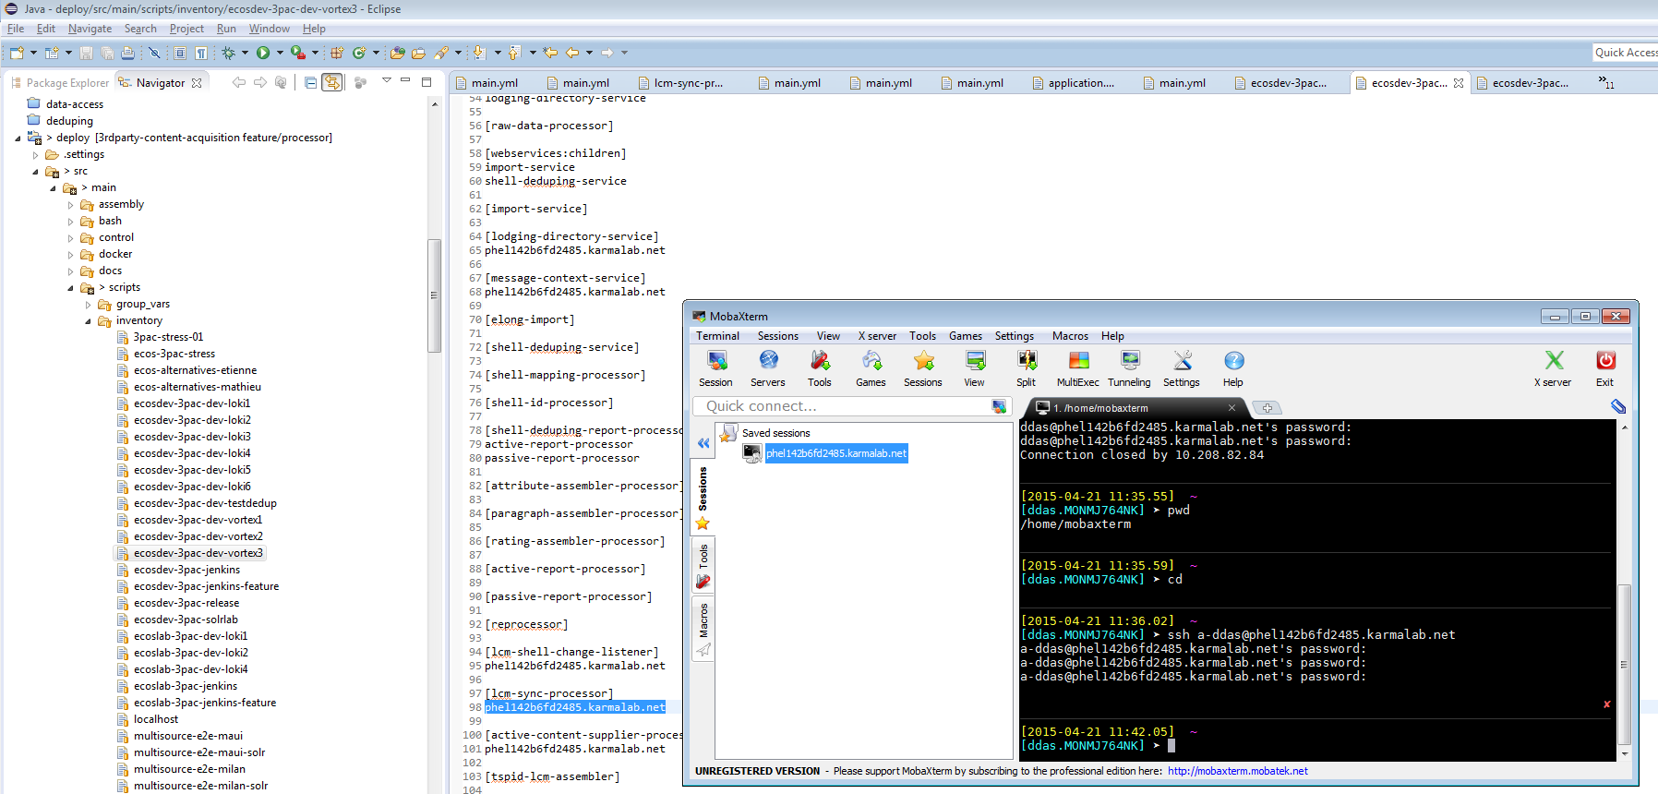

To request access:

1. <https://expedia.service-now.com/com.glideapp.servicecatalog_cat_item_view.do?v=1&sysparm_id=4b275188cdb8050062a9edaea147518e&sysparm_link_parent=1433cd130503fc40f1cbb7981f17ce9e&sysparm_catalog=e0d08b13c3330100c8b837659bba8fb4&sysparm_catalog_view=catalog_default>

(DO NOT FOLLOW THE LINK – CUT AND PASTE IT MANUALLY OTHERWISE YOU WON’T GET TO THE RIGHT PLACE)

1. Request to be added to the following groups:
   1. KARMALAB\LSS_Admins
   2. KARMALAB\LSSDBDev
   3. KARMALAB\Developers

Fill in for each group and “Order Now”:

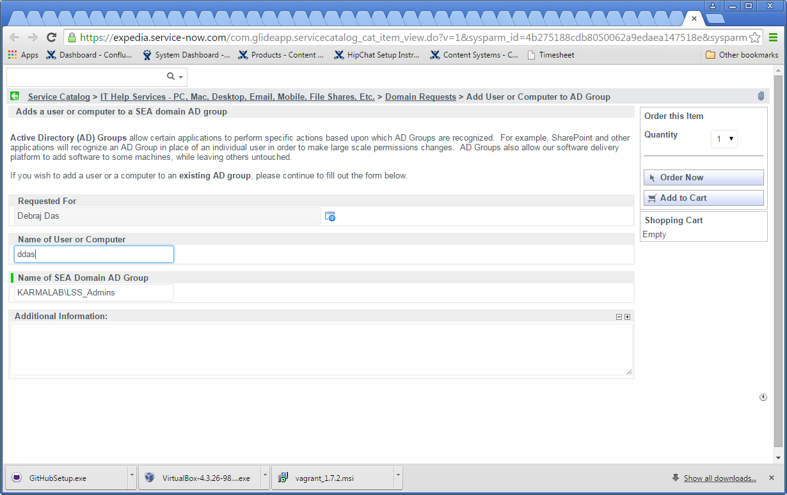

# Get Access to Vortex ECOS Linux Environments

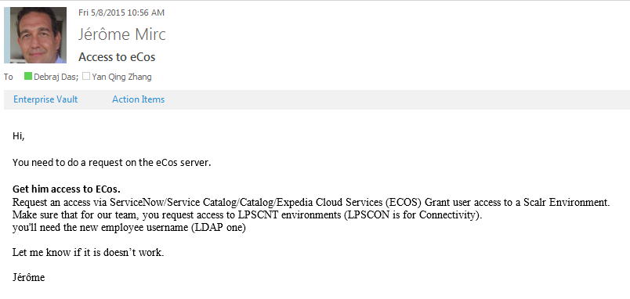

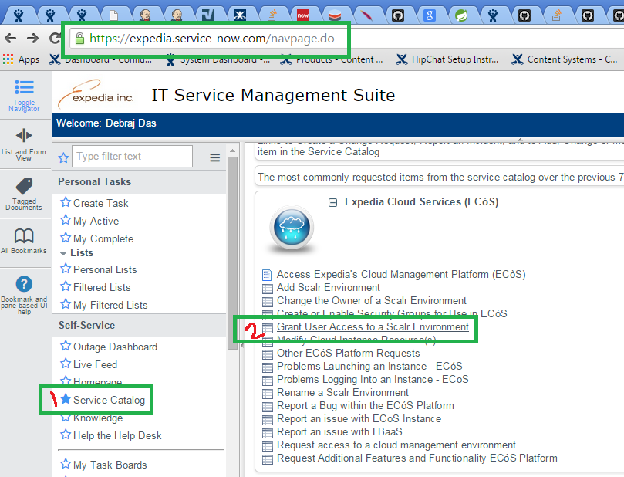

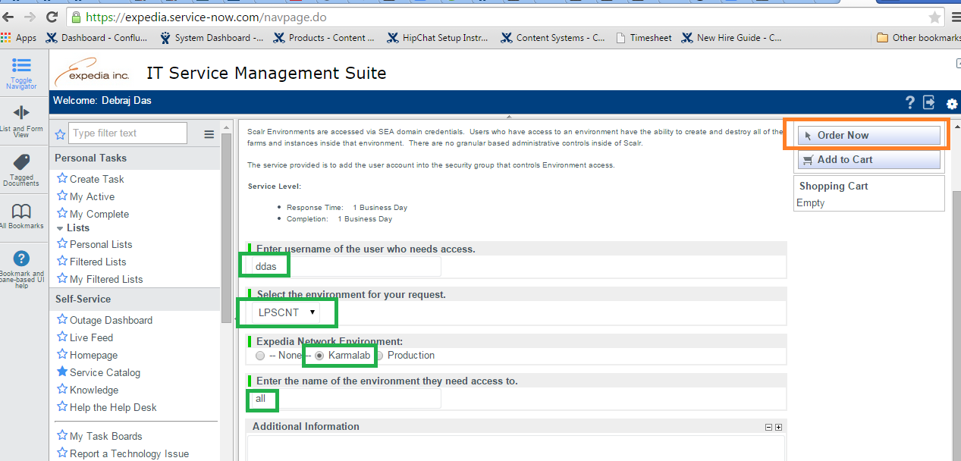

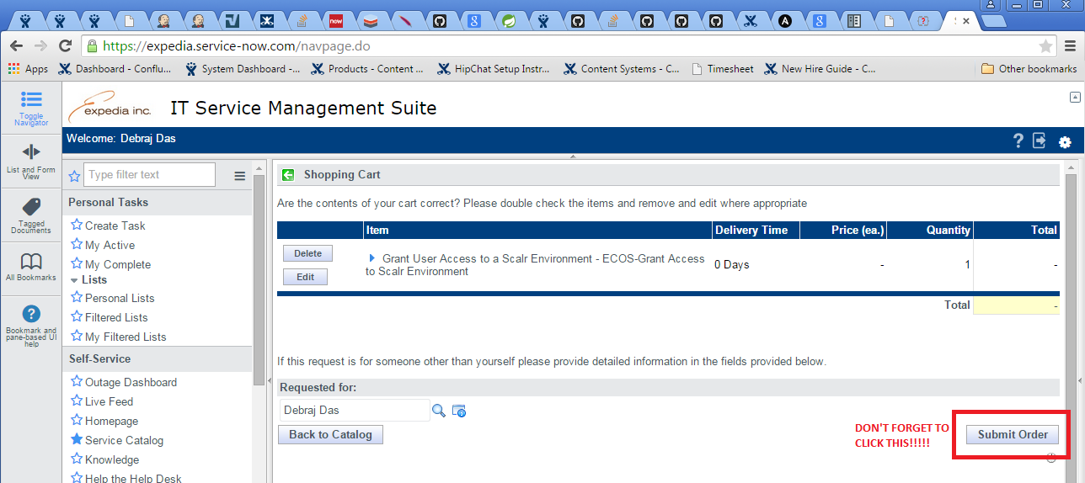

If all goes well you should see the page below…then you have to wait…

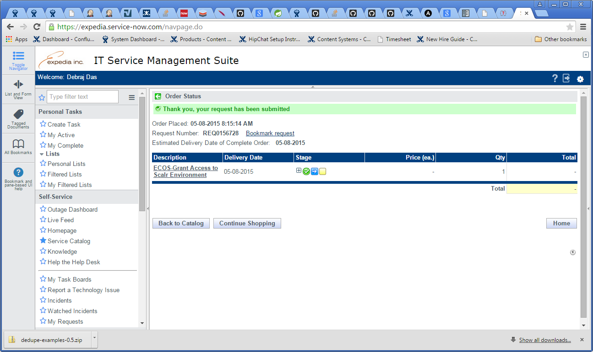

# Specifics for Phoenix

Softwares to install (If not installed Maven can not build the project):

* Exiftool
* ImageMagick

## Exiftool

Pretty straightforward. Make sure the exe file is called “exiftool.exe” on your computer. Add the containing folder to your system PATH variable.

## ImageMagick

I installed ImageMagick-6.9.1-Q8 and the version was important.